[1] "checking Julia version"
'julia version 1.12.6'

ls("package:gswdesign")
# The package has following functions 'gswdesign_setup''gswdesign_update''sample_gs_walk''sample_many_gs_walk''set_julia_seed'

#| Function | Purpose |
#| ----------------------- | ------------------------------------------------------------------------------ |
#| `gswdesign_setup()` | Initializes the package and connects R to Julia. |
#| `gswdesign_update()` | Updates the underlying Julia package. |
#| `sample_gs_walk()` | Generates a single treatment assignment using the Gram–Schmidt Walk algorithm. |
#| `sample_many_gs_walk()` | Generates multiple treatment assignments. |
#| `set_julia_seed()` | Sets the random seed in Julia for reproducible results. |

index
60.5
X1
0.05
X2
-0.03
X3
0
X4
-0.07
X5
0.87
X6
0.5
Total Rows in df_sample : 120[1] "Display first 10 rows of the Selection Order Matrix, generated"
A data.frame: 10 × 2
 | Probs | Treat
 | <dbl> | <dbl>
1 | 0.5 | 2
2 | 0.0 | 1
3 | 0.5 | 1
4 | 1.0 | 2
5 | 0.5 | 1
6 | 1.0 | 2
7 | 0.5 | 1
8 | 1.0 | 2
9 | 0.5 | 1
10 | 1.0 | 2
[1] "# Display first 10 rows and first 7 columns of the augmented SOM."
A data.frame: 10 × 8
 | Treat | index | X1 | X2 | X3 | X4 | X5 | X6
 | <dbl> | <dbl> | <dbl> | <dbl> | <dbl> | <dbl> | <dbl> | <dbl>
1 | 2 | 91 | 2 | 1 | 0 | -3 | 5 | 1
2 | 1 | 28 | 0 | 1 | 0 | -3 | 6 | 0
3 | 1 | 44 | 3 | 3 | 0 | 0 | 2 | 0
4 | 2 | 18 | -2 | -1 | 2 | 3 | 2 | 1
5 | 1 | 27 | 1 | 0 | -1 | 2 | 5 | 1
6 | 2 | 70 | 4 | 1 | -1 | 2 | 0 | 0
7 | 1 | 120 | 0 | -2 | 1 | -2 | 0 | 1
8 | 2 | 111 | 0 | 0 | 2 | -3 | 0 | 0
9 | 1 | 29 | -2 | 0 | 2 | 1 | 0 | 1
10 | 2 | 15 | 0 | -2 | 0 | -2 | 0 | 0
[1] "Printing z_fsm_obs generated from df_sample_aug$Treat Format 1 2 1 1 1 1 2 2 2 2 2 2 1 1 2 2"
[1] 1 2 1 1 1 1 2 2 2 2 2 2 1 1 2 2 2 2 2 2 1 1 2 1 2 1 1 1 1 1 1 1 1 1 2 1 1
[38] 1 1 2 1 2 1 1 2 2 1 1 1 2 1 1 2 2 1 1 1 1 1 1 1 1 2 2 1 2 1 2 2 2 1 2 2 1
[75] 2 1 2 1 2 2 2 1 2 1 2 2 2 1 2 1 2 2 2 2 2 2 2 1 2 1 2 1 2 1 2 1 1 1 2 1 2
[112] 2 1 2 2 1 2 2 2 1
[1] "Generate an assignment under CRD from df_sample - sway"
[1] "Printing Z_crd from df_sample"
[1] 1 1 2 1 2 2 2 2 2 1 1 2 1 1 2 1 2 1 2 2 1 2 1 2 1 2 2 1 2 2 2 1 2 1 1 2 1
[38] 1 1 1 2 2 1 1 1 2 2 2 2 1 2 2 1 1 2 2 1 1 2 1 1 2 2 2 1 1 2 1 2 1 1 1 2 1
[75] 1 2 1 2 1 2 1 1 1 2 2 2 2 1 2 1 2 1 2 1 1 2 2 1 2 1 2 2 1 1 2 1 2 1 2 1 2
[112] 2 2 1 2 1 1 1 2 1
[1] "Generate a sample dataset from matrix(rnorm(840), nrow=120) - sway"
[1] "Output from sample_gs_walk() using df_sample - Generates a single treatment assignment (TRUE or False) using the Gram–Schmidt Walk algorithm."
[1] "Z_gswd - the assignment - output from sample_gs_walk(as.matrix(df_sample[,-1]), phi = 0.3) in TRUE or FALSE Fformat"
[1] FALSE TRUE FALSE FALSE FALSE FALSE TRUE FALSE FALSE FALSE TRUE TRUE
[13] TRUE TRUE FALSE TRUE TRUE TRUE FALSE TRUE FALSE FALSE FALSE TRUE
[25] TRUE TRUE FALSE TRUE FALSE FALSE FALSE TRUE FALSE FALSE TRUE FALSE
[37] TRUE TRUE TRUE TRUE FALSE TRUE TRUE TRUE FALSE TRUE FALSE FALSE
[49] TRUE TRUE TRUE FALSE TRUE FALSE TRUE FALSE TRUE FALSE TRUE TRUE
[61] FALSE FALSE TRUE TRUE TRUE FALSE TRUE TRUE FALSE TRUE FALSE FALSE
[73] TRUE TRUE FALSE FALSE FALSE FALSE FALSE TRUE FALSE FALSE TRUE FALSE
[85] TRUE FALSE TRUE TRUE TRUE TRUE FALSE TRUE TRUE FALSE FALSE TRUE
[97] FALSE TRUE TRUE FALSE FALSE TRUE TRUE FALSE TRUE TRUE FALSE FALSE
[109] FALSE FALSE FALSE TRUE TRUE TRUE TRUE FALSE TRUE FALSE FALSE FALSE
[1] "Z_gswd - the assignment - output from sample_gs_walk(as.matrix(df_sample[,-1]), phi = 0.3) in 2 or 1 format"
[1] 1 2 1 1 1 1 2 1 1 1 2 2 2 2 1 2 2 2 1 2 1 1 1 2 2 2 1 2 1 1 1 2 1 1 2 1 2
[38] 2 2 2 1 2 2 2 1 2 1 1 2 2 2 1 2 1 2 1 2 1 2 2 1 1 2 2 2 1 2 2 1 2 1 1 2 2
[75] 1 1 1 1 1 2 1 1 2 1 2 1 2 2 2 2 1 2 2 1 1 2 1 2 2 1 1 2 2 1 2 2 1 1 1 1 1
[112] 2 2 2 2 1 2 1 1 1
[1] "Love plot (1) of the TASMDs in T_1 for FSM and CRD using df_sample"
[1] "----------------------------------------------------------------"
[1] "Love plot (2) of the TASMDs in T_1 for FSM and GSWD using df_sample"
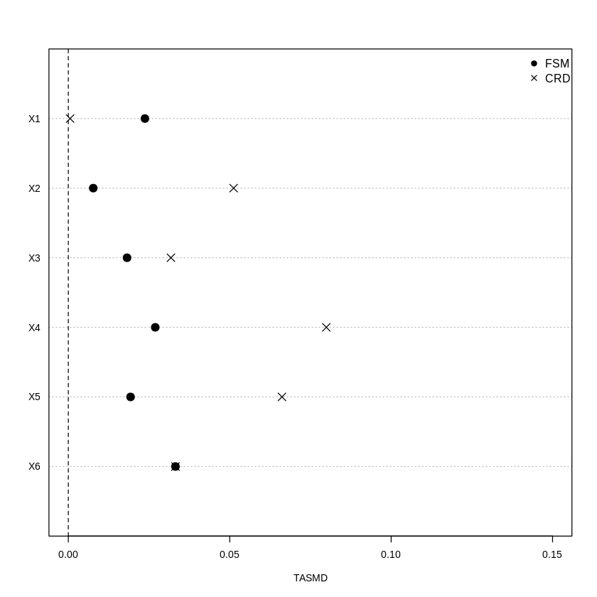
[1] "----------------------------------------------------------------"
[1] "Love plot (3) using TASMDs for df_sample_sq_int for FSM and CRD using df_sample_sq_int i.e., squares and products of continuous covariates"
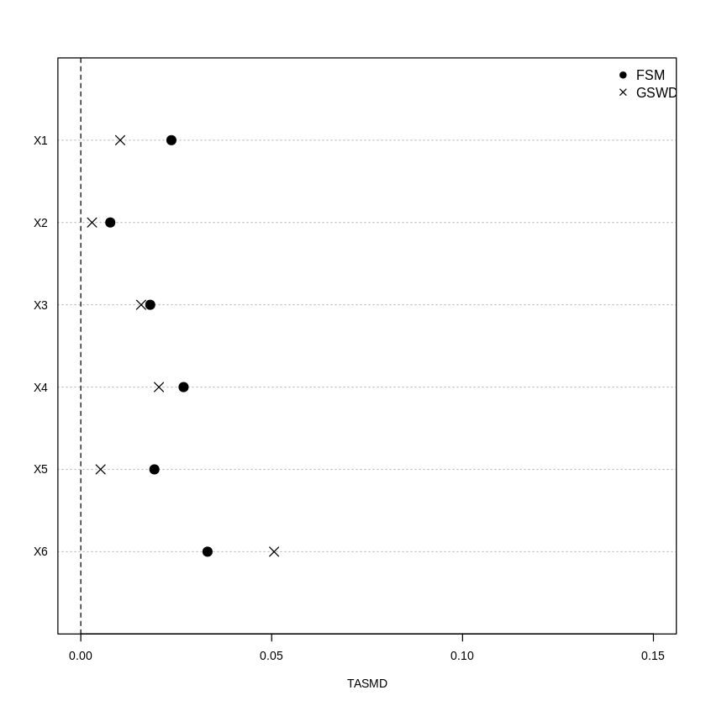
[1] "----------------------------------------------------------------"
[1] "Love plot (4) using TASMDs for df_sample_sq_int for FSM and GSWD using df_sample_sq_int i.e., squares and products of continuous covariates"
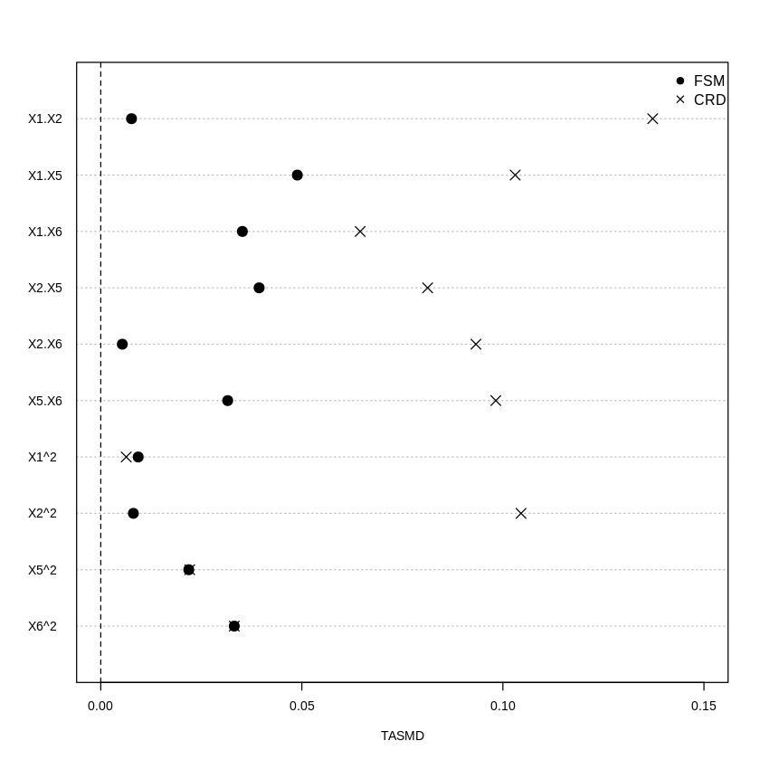
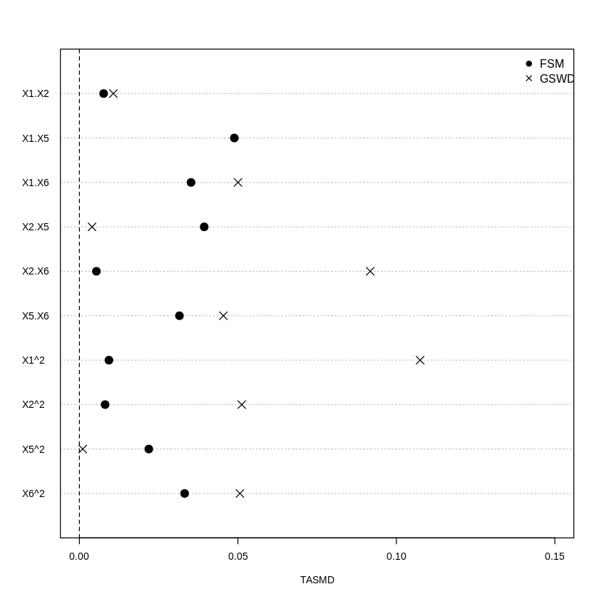

[1] "Generate assignment under 5 Designs - CRD, rerandomization .01, rerandomization .001, FSM and GSWD"

[1] "Diagnostic begins"
[1] "Estimated densities of the ASMDs under each design, i.e. CRD, FSM, RR 0.01 and RR 0.001"
[1] "Estimated densities of the ASMDs under two design i.e. FSM and GSWD"
[1] "Density Plot - ASMD Main Covariates- mean ASMD"
[1] "Density Plot - ASMD Main Covariates- mean ASMD for FSM and GSWD"
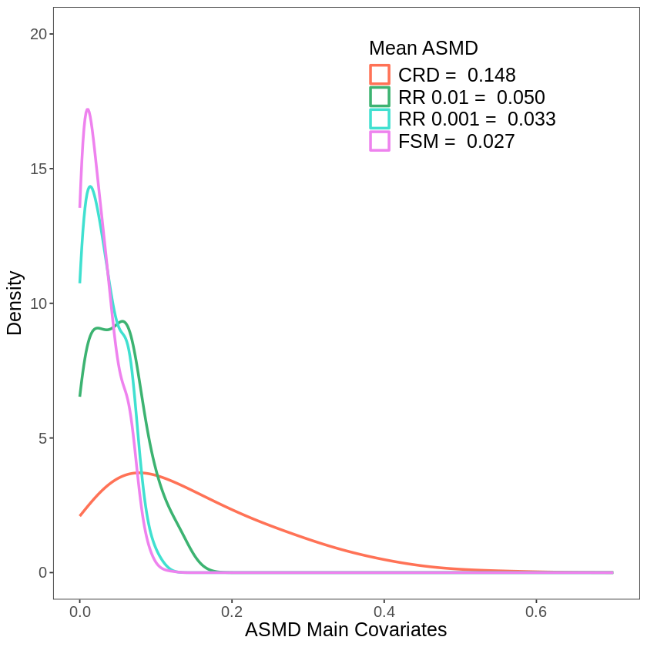
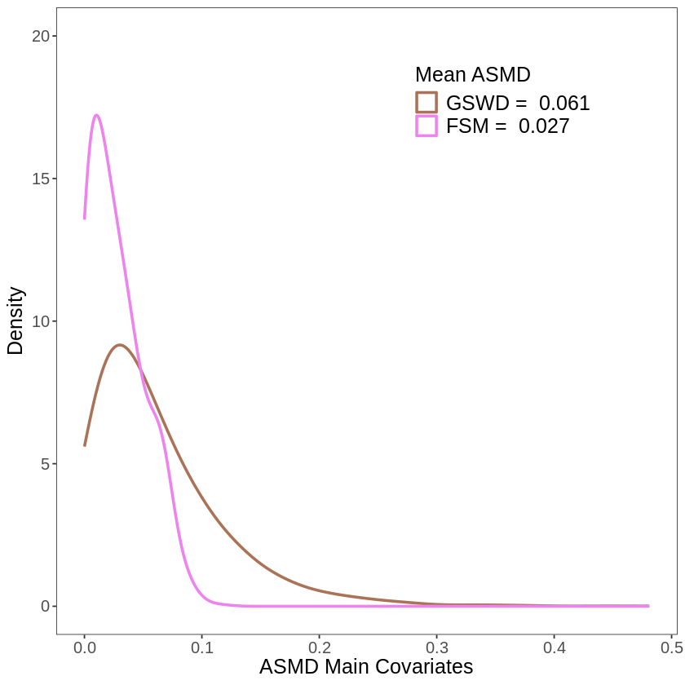

[1] "Sqaures and Interactions for all four designs i.e CRD, FSM, RR 0.01 and RR 0.001"
[1] "Sqaures and Interactions for GSWD and FSM"
[1] "Estimated densities ASMD Squares and Interaction for CRD, RR 0.01, RR 0.001, FSM"
[1] "Estimated densities ASMD Squares and Interaction for GSWD and FSM"
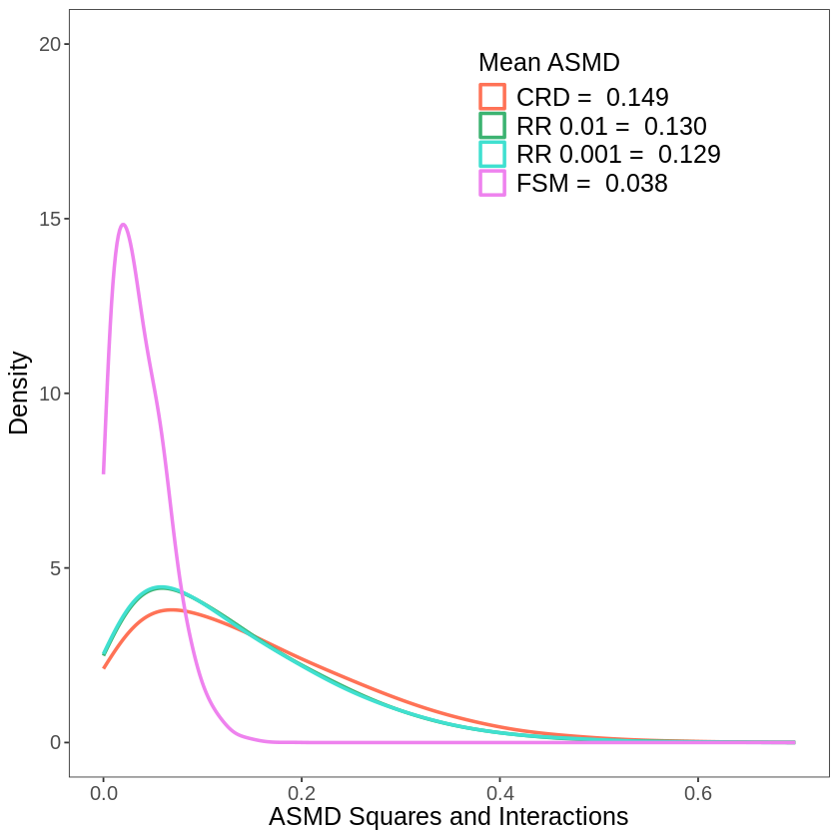
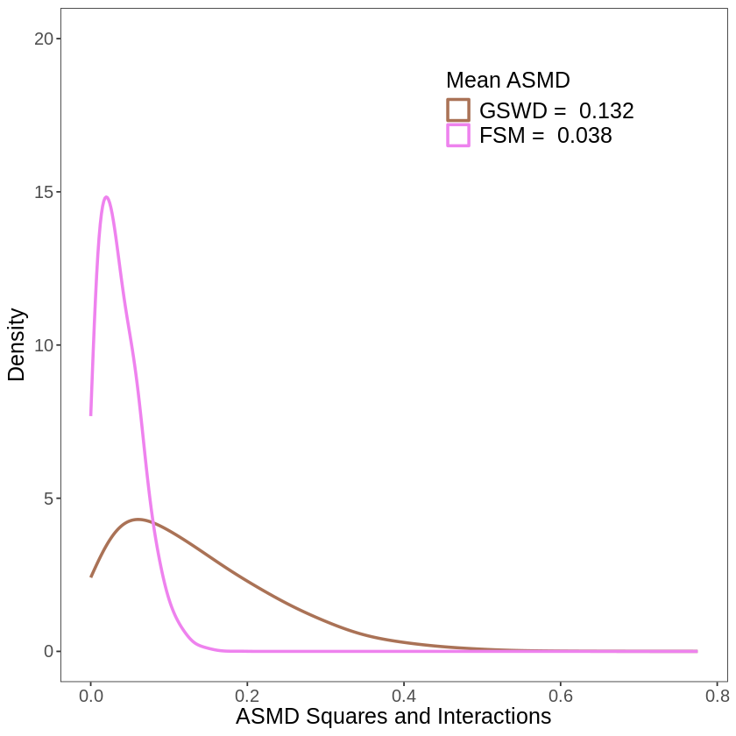
[1] "Frobenius Norm for CRD, RR 0.01, RR 0.001, FSM, GSWD"
